### Background on Energy Usage in Greenhouse

73% of energy consumed by greenhouses in Ontario Canada are fueled by natural gas and 18% from electricity. Most of the energy is consumed by the vegetable sub-sector.

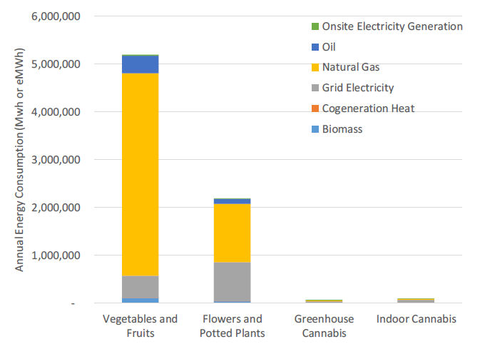

• A lit vegetable greenhouse consumes 10 times as much electricity as an unlit vegetable greenhouse, with essentially all the additional electricity used for lighting.

• A lit flowers greenhouse consumes 4 times as much electricity as an unlit vegetable greenhouse.

• Indoor cannabis facilities use almost 3.5 times more electricity per square foot than lit vegetable greenhouses.

• Indoor cannabis facilities use 1.4 times more electricity than cannabis produced in greenhouses.

**Forecasted Energy Consumption has been constantly growing:** 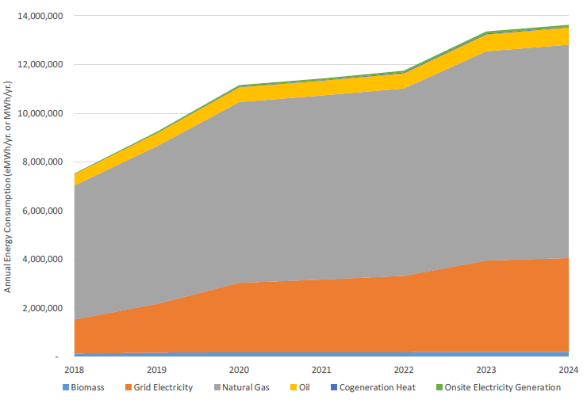

Maintaining the ideal temperature within the greenhouse is the most important aspect of the thermal management systems of a greenhouse operation. *Max and minimum temperatures must be maintained to avoid plant stress or loss.*

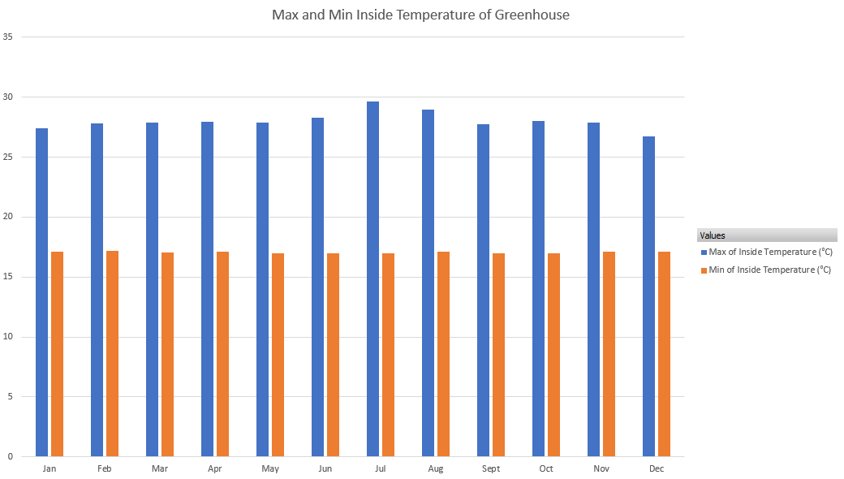

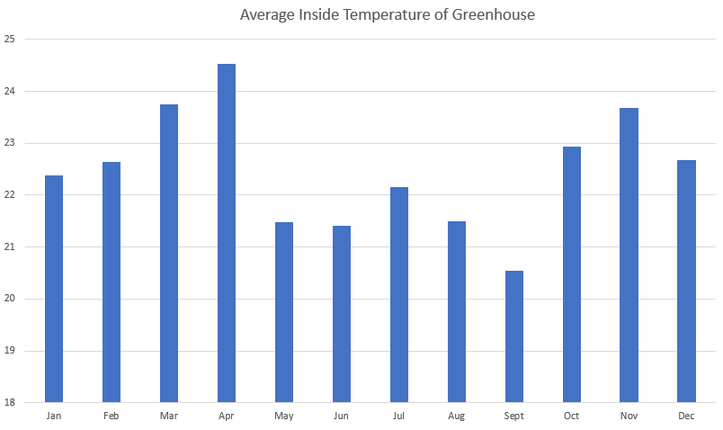

The monthly average temperatures inside a greenhouse throughout the year, revealing a fluctuating pattern with distinct seasonal peaks. The highest temperatures, reaching a maximum of approximately 24.5 degrees in April, followed by a noticeable drop during the summer months (May through September), where the average falls to its lowest point of about 20.5 degrees in September. Temperatures then rebound significantly in the autumn, with November seeing averages near the highs, suggesting that the greenhouse environment is maintained at its warmest during the transitional seasons and during the winter.

### Analysis Major Assumptions:

Our analysis is based on the following major assumptions:

1. **Steady-State Conditions:** The system is assumed to operate at a constant, unchanging state over time.
2. **Adiabatic System:** We assume no heat is lost to the surroundings (i.e., the system is perfectly insulated).
3. **Ideal Heat Transfer:** The heat exchanger is modeled as ideal, implying maximum possible heat transfer efficiency.
4. **Incompressible Flow:** Fluid properties (such as density and specific heat) are treated as constant.

*The size of the data centre is 10 MW which satisfies 10 MW heating demand of the greenhouse if no other heating source is utilized.*

In general, at lower latitudes (40 to 50 degrees the heating requirements range from 250 to 430 kWh/m2/y, whereas, in higher latitudes (50 to 60 degrees) the heating needs range from 430 to 650 kWh/m2/y ([Source](https://www.mdpi.com/1996-1073/16/19/6788)). In terms of size of greenhouse, basically high tech greenhouses produce 250 to 600 tonnes of tomatoes per hectare ([Source](https://hydroponicsystems.eu/tomato-yields-per-hectare-in-greenhouses/)).

| **User of excess heat is:** | **External use** |
| --- | --- |
| Type of heat recovery: | HEX (separation) and HP (boost) |
| Heat source: | Data center cooling (fluid) |
| Excess heat available capacity: | 10 MW |
| Excess temp. supply side: | 30˚, 45˚, 60˚C |
| Excess temp. return side: | 18˚, 33˚, 48˚C |
| Heat demanded by user: | 10 MW |
| Supply temp. from HP: | 28, 43, 45, 50, 58, 65, 91 ˚C |
| Return temp. from consumer: | 31, 32, 35, 40, 46, 50 ˚C |
| Current type of heating: | Gas Boiler |
| Cost of current type of heating: | 0.08 €/kWh |
| Cost of electricity: | 0.08 €/kWh |
| Agreed heat sales price: | 0.01 €/kWh |

### **Where is the heat going? The complexity of Datacenter heat and Greenhouse heating needs**

The undertaking of this study revealed a significant challenge pertaining to the thermal mismatch between the consistent heat output from a data centre and the seasonally and daily fluctuating requirements of a greenhouse. In conventional greenhouse operations, this challenge is typically mitigated by incorporating a thermal storage tank—a large water reservoir that stores thermal capacity, charging and discharging throughout the day to meet varying set points across different greenhouse zones. Although modelling the required thermal storage capacity was beyond the scope of this current work and was not conducted, it must be factored into the development of system scale, size, integration planning, overall costs, and design.

One key insight derived from this study was that the distinct temperature set points across various greenhouse zones could present multiple thermal load options for integrating heat rejected from data centres. The simplest and most straightforward integration would involve directing the rejected heat directly into the thermal storage tank. However, a hurdle remains, as the primary heating source for these tanks—the boilers—produces heat at temperatures ranging from 91 to 94 degrees Celsius. The return temperature of the rejected heat from the greenhouse varies based on the season and time of day, generally falling within the 30-35 degrees Celsius range, occasionally lower. These temperatures typically necessitate upgrading the data centre's rejected heat.

Further investigation into temperature and heating zone requirements highlighted a few critical points, notably the consistent and lower-temperature load requirements associated with in-floor heating and root zone heating systems, which are essential to avoid plant damage. Providing a substantial amount of heating in these lower-temperature zones within the greenhouse envelope consequently reduces the need for the much higher-temperature heating typically employed in other zones by traditional greenhouse operators utilizing large natural gas boilers.

An opportunity exists to develop an optimized heating protocol for greenhouses that capitalizes on the lower-temperature heat available from data centre thermal energy networks. By utilizing this heat in areas with lower temperature requirements, the need to upgrade the heat to higher temperatures using heat pumps—thereby consuming more electrical load and increasing greenhouse operational costs—is diminished. This study modelled various potential heat provision locations and examined different scalable sizing ratios between data centres and greenhouses, accounting for the seasonal and peak load requirements concerning both rejected heat and its utilization.

### **Greenhouse Temperature Set points:**

Root zone heating can provide 25% to 50% of the total heat needs of the greenhouse, depending upon the climate. For optimum growth, most plants need soil temperatures of 21°C – 24°C, which is difficult to achieve with forced-air heaters. By delivering heat directly to the roots, the overall greenhouse temperature can be reduced, saving up to 20% to 30% of fuel costs. ([Source](https://www.stuppy.com/blog-posts/heat2o-bt-hydronic-heat-produces-better-crops-and-saves-money/), [Source](https://farm-energy.extension.org/root-zone-heating-systems-for-greenhouses/))

[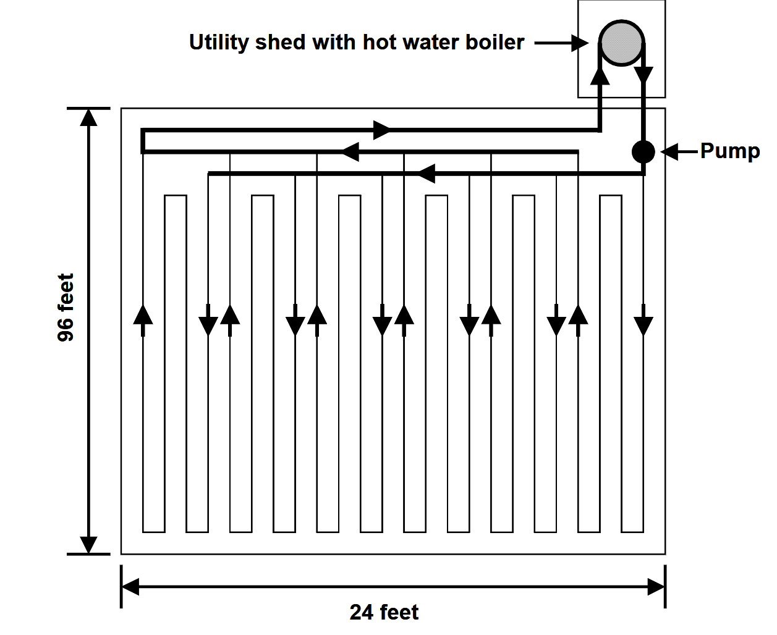](https://ceac.arizona.edu/sites/default/files/aj_both_-_root_zone_heating.pdf)

### The floor heating system usually provides only 30-40% of the annual heat requirement of a double-layered greenhouse structure. The additional heat must be provided by an overhead heating system.

### The water temperature in a floor heating pipe loop operating temperatures maintained between 32°C and 49°C should rarely exceed this ([Source](https://ceac.arizona.edu/sites/default/files/aj_both_-_root_zone_heating.pdf)).

These temperatures offer a novel possibility for data centre rejected heat coming out at 30°C - 45°C temperatures.

### Ambitious Scenario: Direct Thermal Integration

This scenario represents the maximum potential for synergistic integration, aiming for the highest possible waste heat utilization rate.

**Principle:** Direct utilization of low-grade datacenter waste heat to supply the majority, if not all, of the thermal energy required for greenhouse vegetable cultivation.

The hot air or fluid (e.g., water or a specific coolant) exiting the datacentre's cooling system is immediately routed to the greenhouse's heating infrastructure. This involves an air-to-air heat exchanger system or, more efficiently, a liquid-to-air heat pump/exchanger system that directly supplies the greenhouse's heating pipes (e.g., bench heating, under-bench pipes, or finned-tube radiators).

**Data Center-Greenhouse architect** (100%, 24 hrs heat from Data center)

The foundational assumption for the technical analysis is a hyperscale datacenter with a total waste heat of 10 MW. This heat, typically vented via cooling towers, will be recovered and supplied to a co-located controlled-environment greenhouse via a custom, high-efficiency plate heat exchanger.

Thermal modeling is based on specific ΔT assumptions for optimal operation:

1. Supply Differential: The hot fluid supplied to the greenhouse will be 2 °C lower than the fluid returning from the datacenter.
2. Return Differential: The fluid returning from the greenhouse will be 2 °C lower than the fluid returning to the datacenter's cooling plant.

Water is the primary heat transfer fluid for both loops due to its properties and cost-effectiveness. Pump selection and sizing, along with their energy consumption modeling, are governed by the Affinity Laws and typical efficiencies.

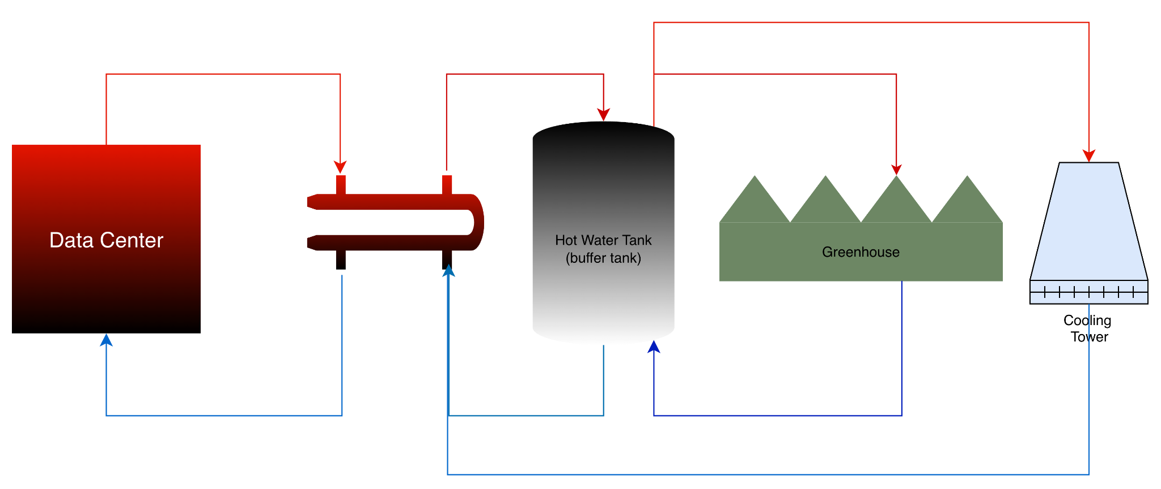

**Studies on the Temperature Output from Data Centre for Ambitious Scenario:**

|  | **Data Centre** (10 MW) | | **Greenhouse** (10 MW) | |
| --- | --- | --- | --- | --- |
| **Study** | Output Temperature | Input Temperature | Output Temperature | Input Temperature |
| 1.1 | 30°C | 18°C | 16°C * | 28°C |
| 1.2 | 45°C | 33°C | 31°C | 43°C |
| 1.3 | 60°C | 48°C | 46°C | 58°C |

*Note: * is not practical output temperature in case of commercial greenhouses unless there is cold and hot storages for the greenhouse.*

**Study 1.1 - DC at 30°C**

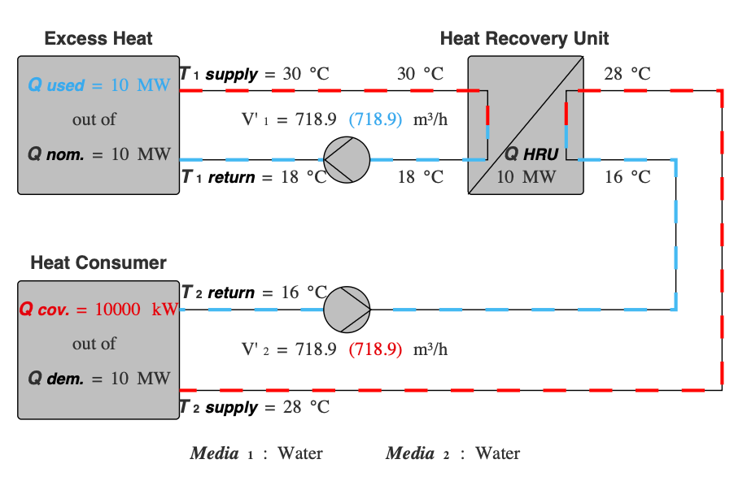

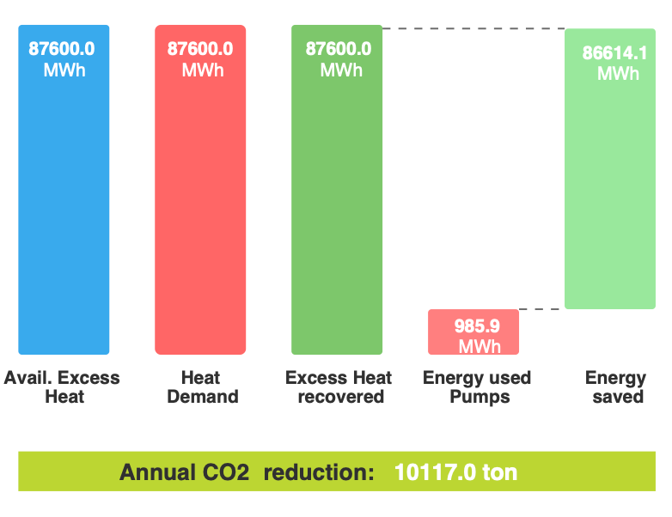

**Study 1.2 - DC at 45°C**

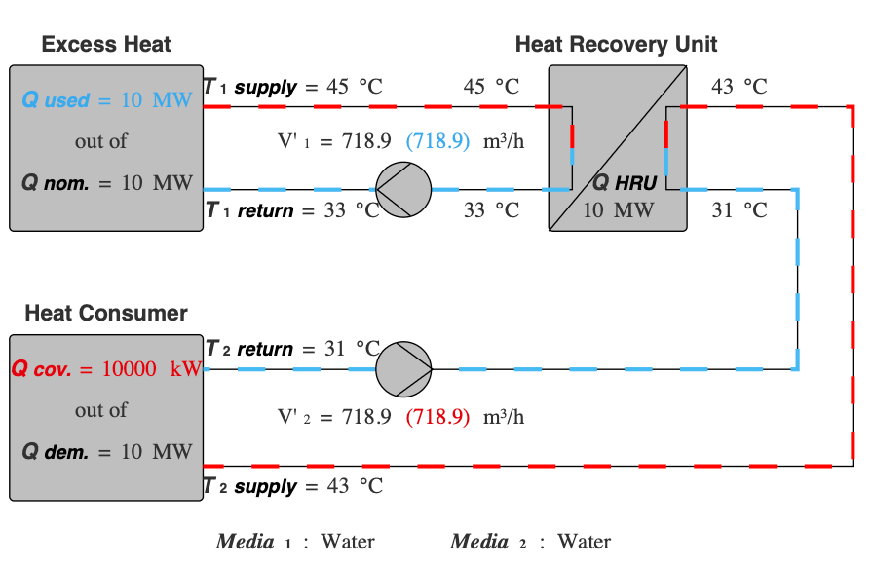

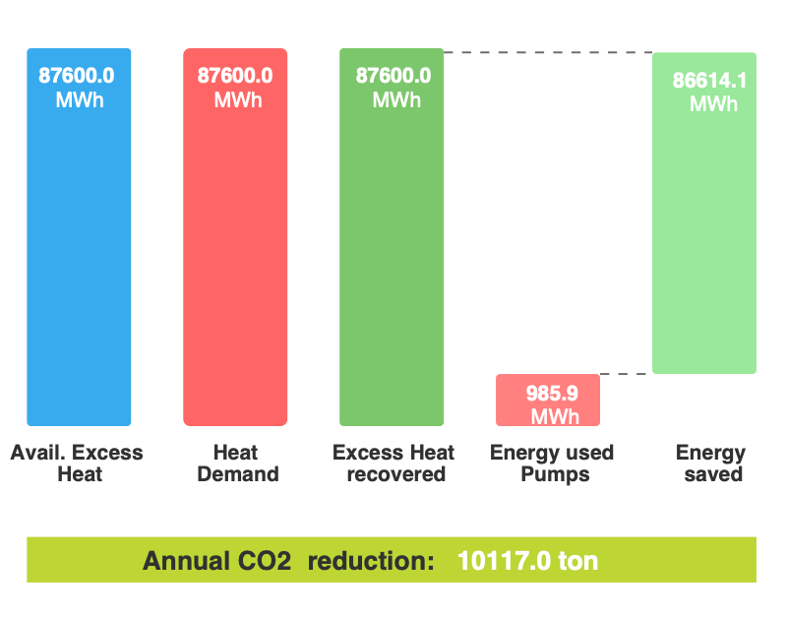

**Study 1.3 - DC at 60°C**

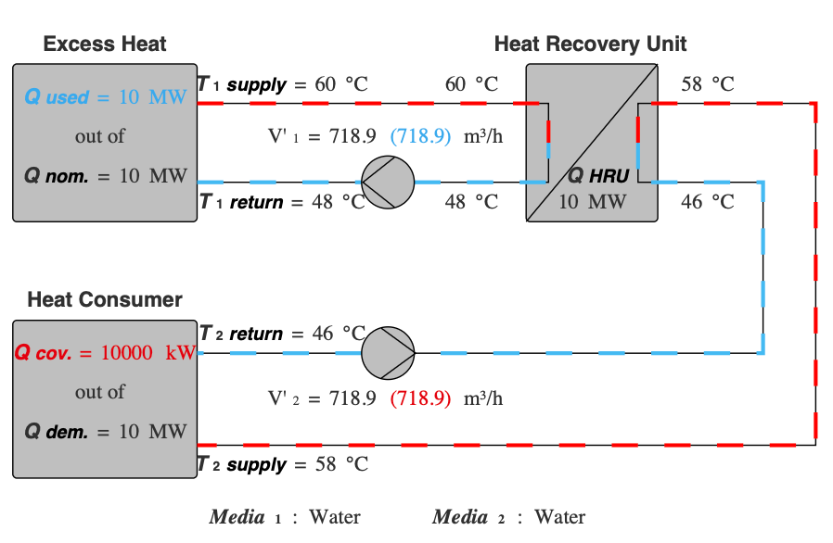

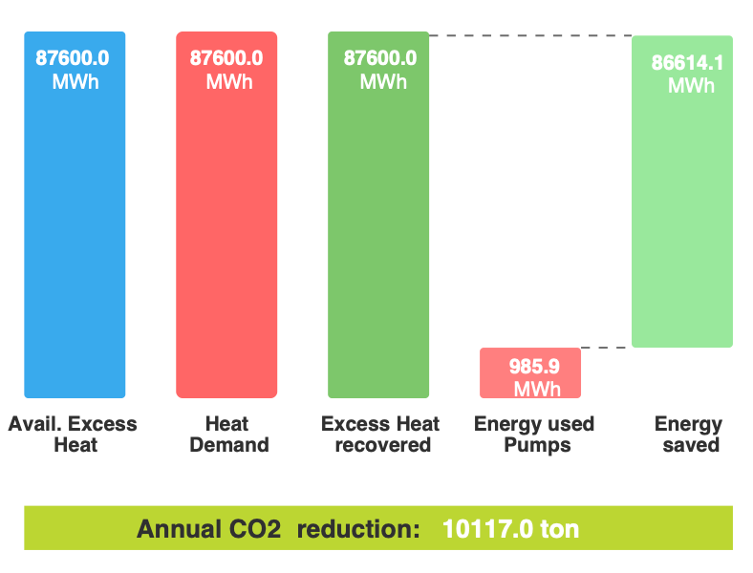

This scenario specifically focuses on designing new greenhouses to utilize the data center's waste heat output. The greenhouse is designed to be fully supplied by the data center's waste heat when required. Critically, this scenario achieves the highest annual CO2 reduction compared to all others because the energy savings are consistent across all three studies.

**Technical Challenge:** The system necessitates stringent control over the datacentre's operational temperature and the greenhouse's heating requirements, as thermal fluctuations in one subsystem directly impact the other. The waste heat temperature produced by the datacentre frequently requires augmentation via a heat pump to achieve the optimal growing temperatures for the greenhouse.

Significant thermal storage capacity will be required and modeled to accommodate seasonal demands, maximizing the utilization of available temperatures and rejected heat. Consideration should be given to geological formations or aquifer storage for thermal energy storage, encompassing both hot and cold storage, to enhance temperature management and ensure crop consistency. Prioritizing the optimization of heating loops within the root zone and in-floor systems is essential to effectively utilize these lower temperatures and maintain superior crop quality.

**Drawbacks:** This configuration offers reduced operational autonomy for both facilities; a system failure in one subsystem carries the risk of critically compromising the operation of the other.

Furthermore, greenhouses employing this design without supplementary investments in industrial boilers and heat pumps to elevate temperatures face substantial risk in the event of severe storms or extreme cold at the site. This scenario is optimally suited for warmer climates, as the temperatures are insufficient to support the rapid snow melting capacity required in regions with snowfall.

Nevertheless, understanding this idealized scenario is valuable as it provides a benchmark against which the performance of alternative configurations, incorporating upgraded heating infrastructure and integrated heat pump systems, can be effectively measured.

### **Theoretical Scenario:** Baseline Heating Satisfaction and Integrated Energy Loop

This scenario focuses on reliable, continuous heat supply to cover the greenhouse's constant, predictable heating load, while formally embedding the datacentre heat source within the existing greenhouse energy infrastructure.

This specific scenario is designed to provide constant heat by targeting the root zone, delivering an input temperature of approximately 40–50°C to the greenhouse. This temperature range is standard for root zone heating systems, as it ensures optimal soil conditions for the plant base, which is necessary for sustaining high-yield production.

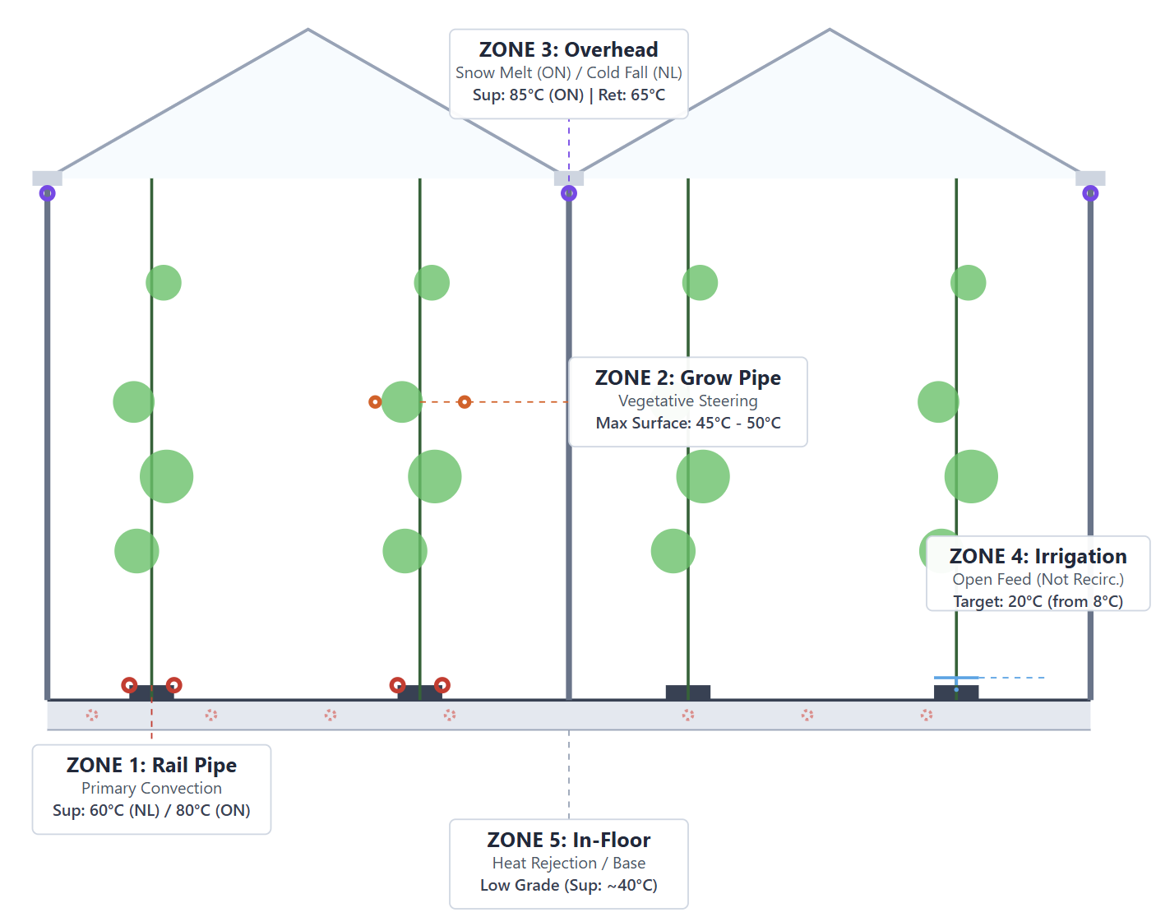

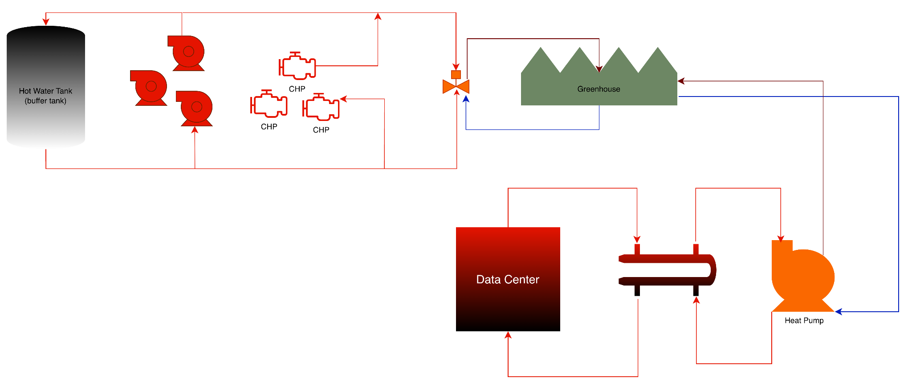

**Studies on the Temperature Output from Data Centre for Theoretical Scenario**

|  | **Data Centre** (10 MW) | | **Greenhouse** (10 MW) | |
| --- | --- | --- | --- | --- |
| **Study** | Output Temperature | Input Temperature | Output Temperature | Input Temperature |
| 2.1 | 30°C | 18°C | 35°C | 45°C |
| 2.2 | 45°C | 33°C | 35°C | 45°C |
| 2.3 | 60°C | 48°C | 40°C | 50°C |

**Study 2.1 - DC at 30°C**

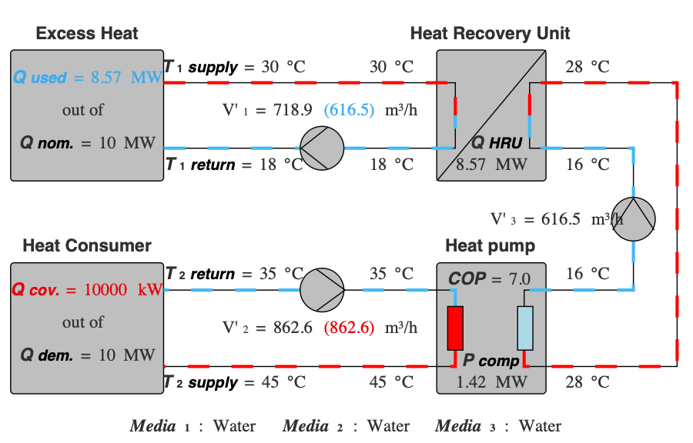

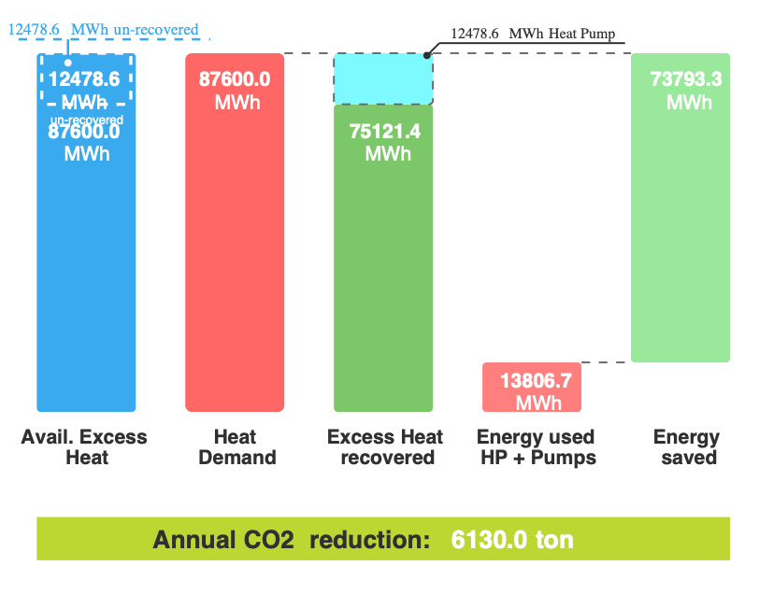

**Study 2.2 - DC at 45°C**

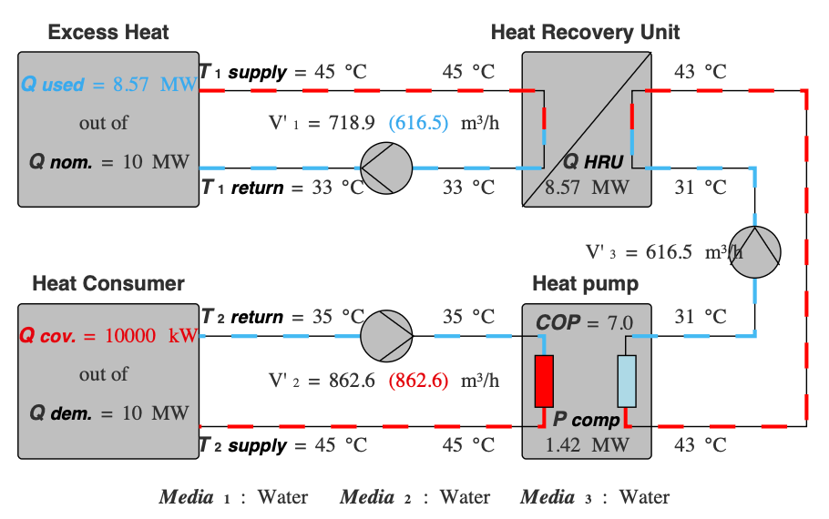

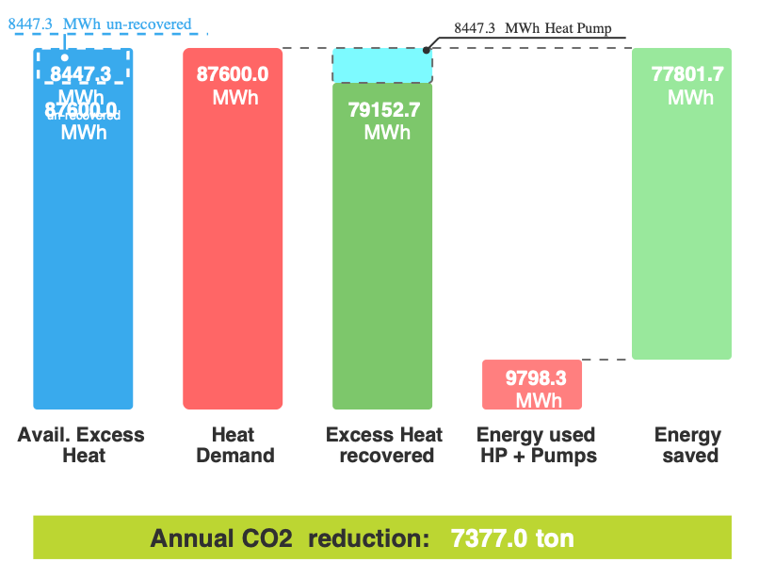

**Study 2.3 - DC at 60°C**

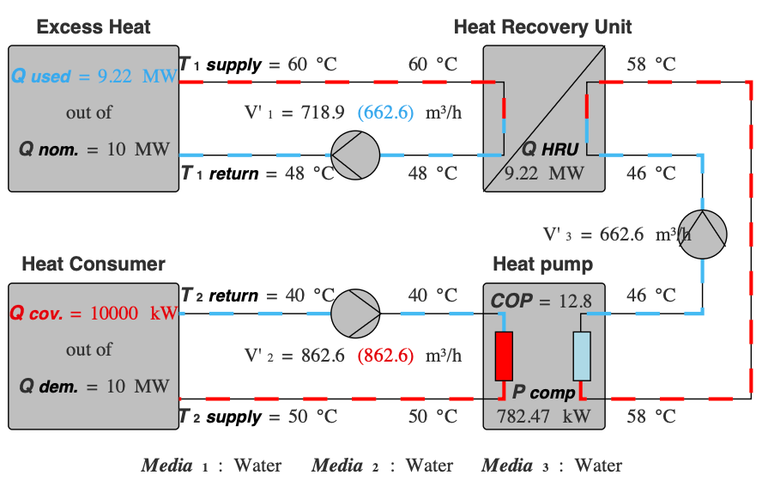

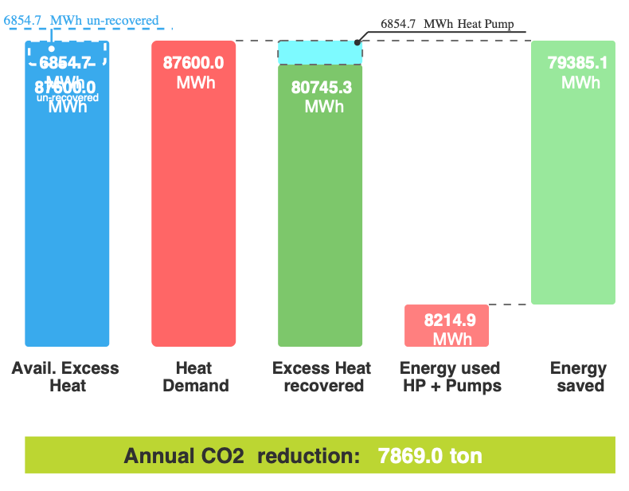

### **Simple Practical Scenario**: Thermal Storage-Centric Approach

This is a highly practical and common approach, utilizing thermal energy storage as a buffer between the two facilities.

Decoupling the real-time heat production (datacenter) from the real-time heat consumption (greenhouse) using a large-capacity hot water storage tank.

All recovered heat from the datacentre is delivered to a dedicated **hot water storage tank** (often referred to as a thermal storage or tank). The greenhouse then draws heat from this storage tank as needed. This approach is highly effective because:

The datacenter can operate consistently, while the greenhouse needs heat intermittently (e.g., high demand at night, low demand during the day). The storage tank manages this temporal mismatch.

**Temperature Buffering:** The tank allows for temperature homogenization, reducing thermal shocks to the greenhouse system.

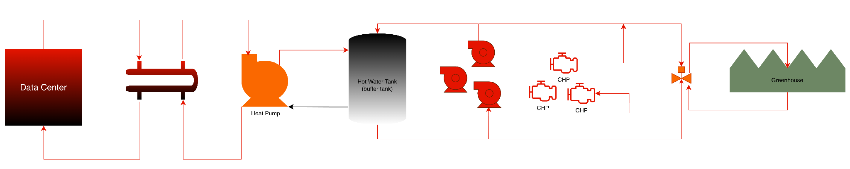

**Studies on the Temperature Output from Data Centre for Simple Practical Scenario**

|  | **Data Centre** (10 MW) | | **Greenhouse** (10 MW) | |
| --- | --- | --- | --- | --- |
| **Study** | Output Temperature | Input Temperature | Output Temperature | Input Temperature |
| 3.1 | 30°C | 18°C | 32°C | 91°C |
| 3.2 | 45°C | 33°C | 32°C | 91°C |
| 3.3 | 60°C | 48°C | 32°C | 91°C |

**Study 3.1 - DC at 30°C**

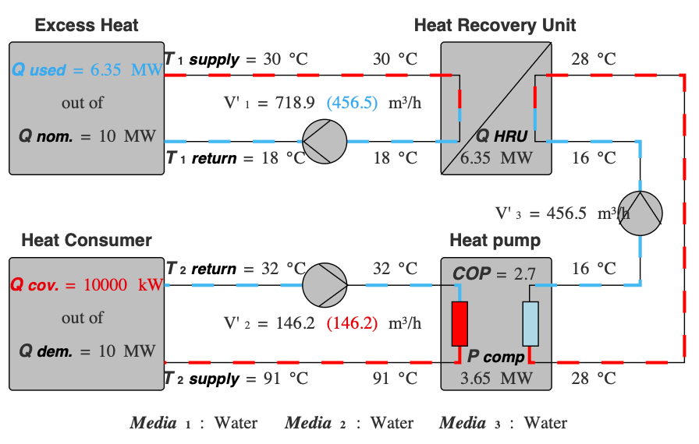

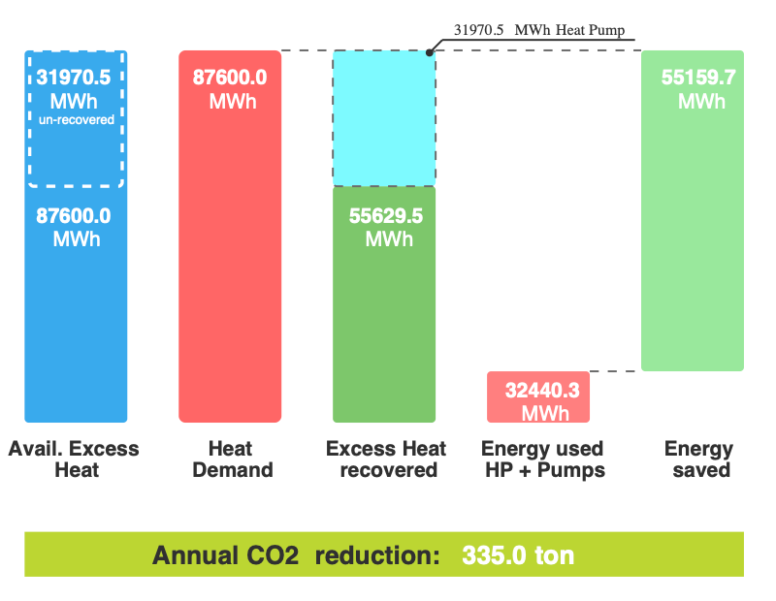

**Study 3.2 - DC at 45°C**

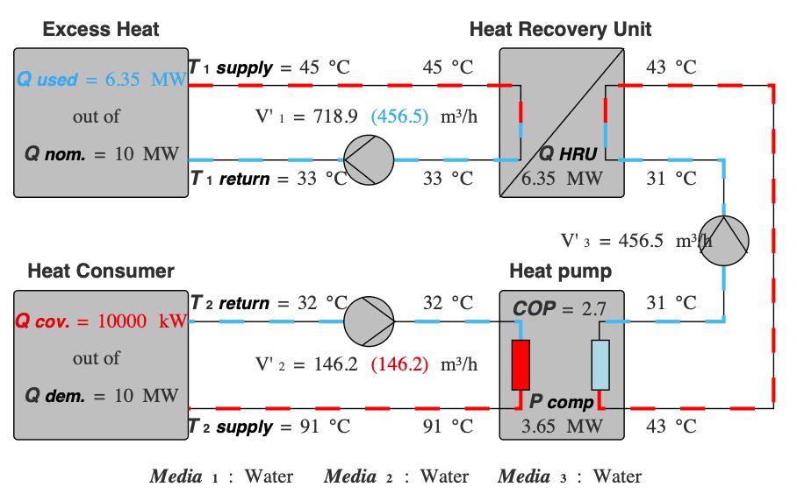

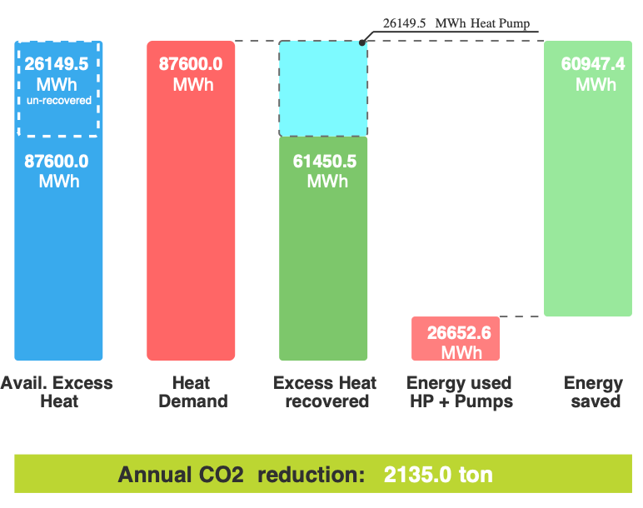

**Study 3.3 - DC at 60°C**

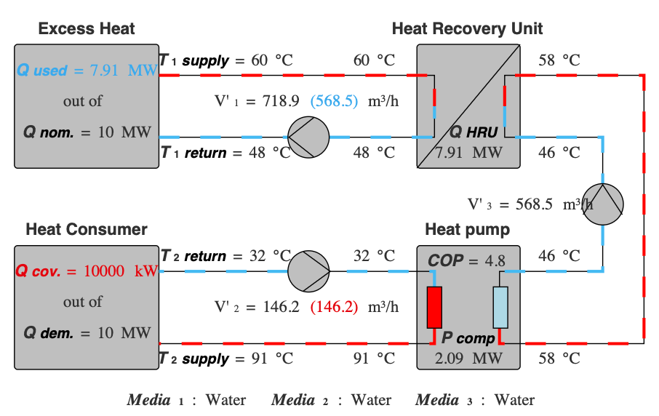

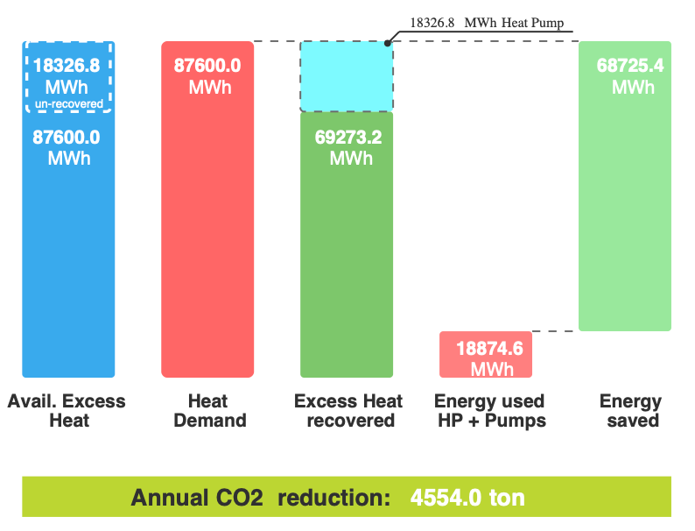

### 

### **Complex Practical Scenario:** Adding heat at point of use

This scenario is focused on using the datacentre heat to pre-condition the primary water inputs to the greenhouse.

Utilizing recovered heat to raise the temperature of the cold water feed before it enters the final heating components. The datacenter heat is supplied directly to the **greenhouse's feed water mixing valve** or a pre-heating stage for the water loop. The main application here is pre-heating the water used for:

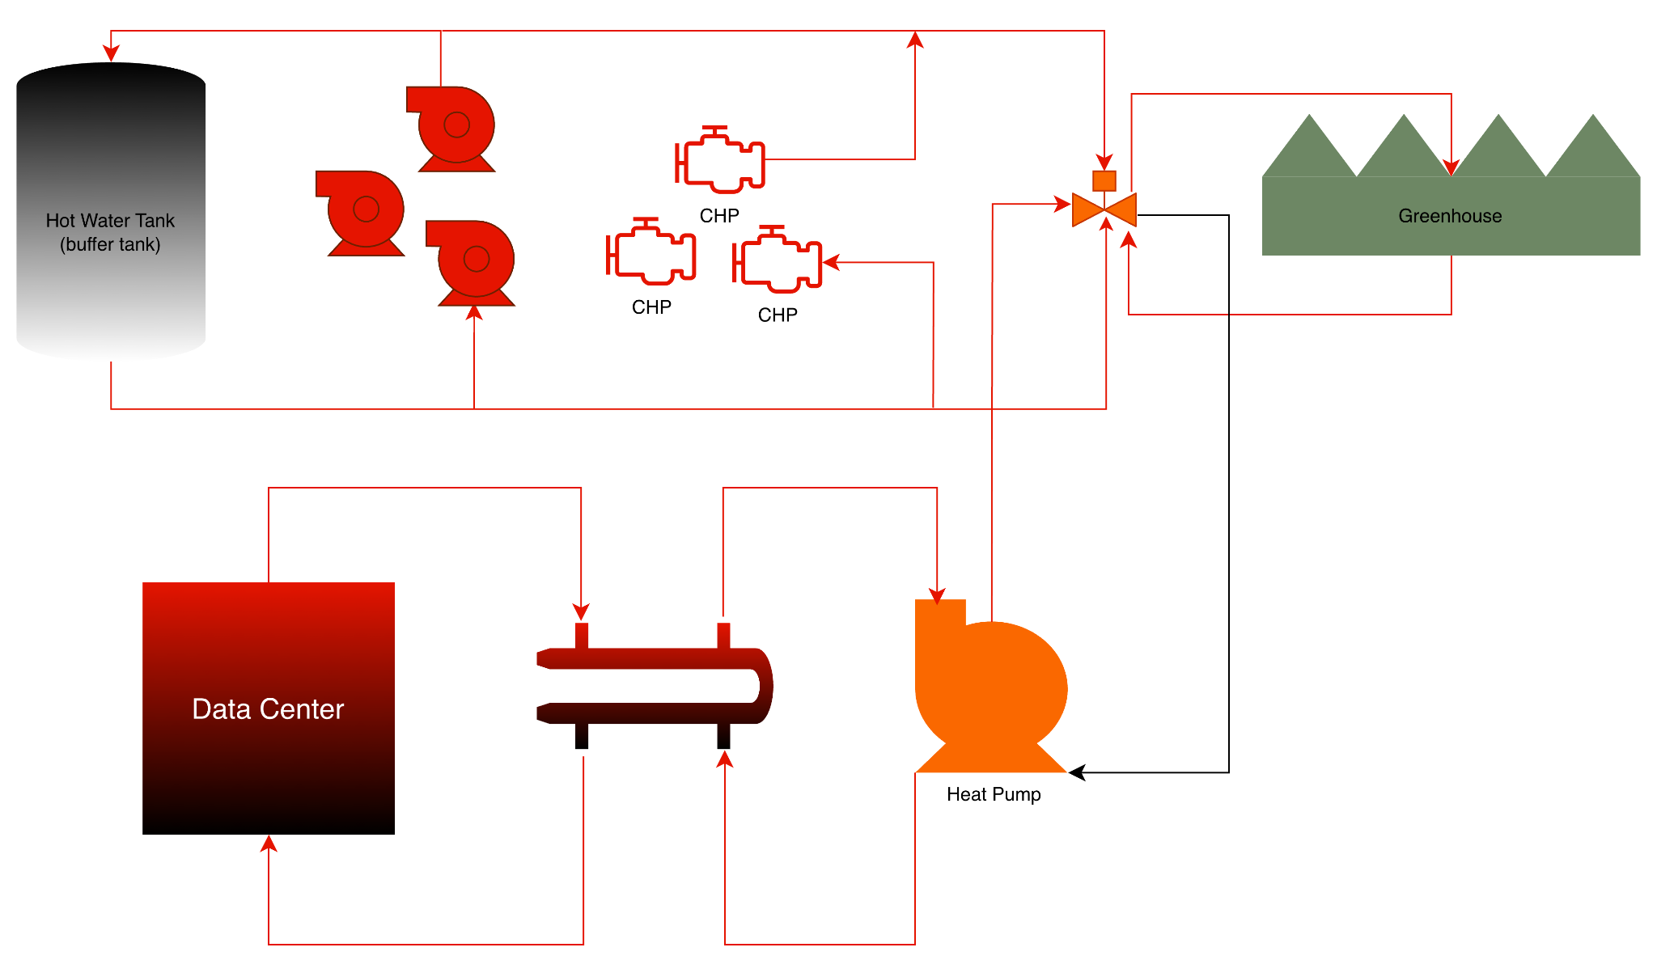

**Studies on the Temperature Output from Data Centre for Complex Practical Scenario**

|  | **Data Centre** (10 MW) | | **Greenhouse** (10 MW) | |
| --- | --- | --- | --- | --- |
| **Study** | Output Temperature | Input Temperature | Output Temperature | Input Temperature |
| 4.1 | 30°C | 18°C | 35°C | 45°C |
| 4.2 | 45°C | 33°C | 35°C | 45°C |
| 4.3 | 60°C | 48°C | 50°C | 65°C |

**Study 4.1 - DC at 30°C**

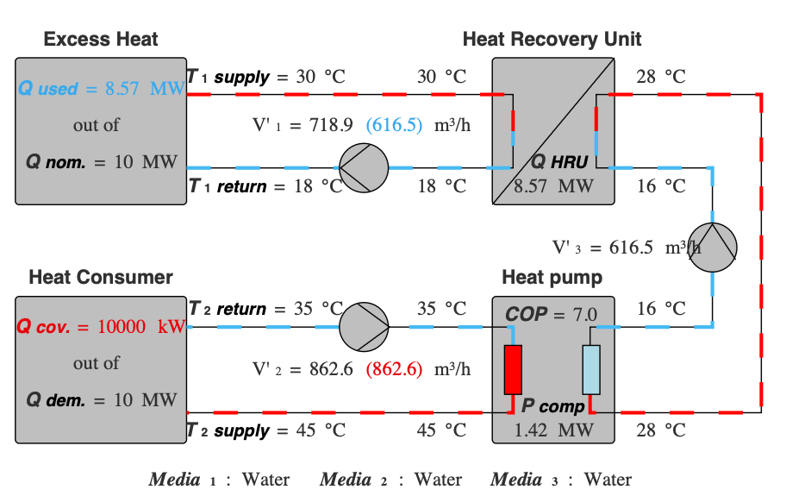

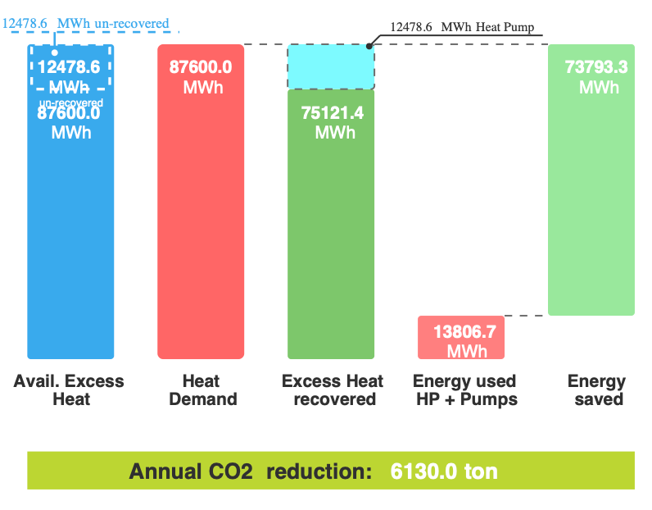

**Study 4.2 - DC at 45°C**

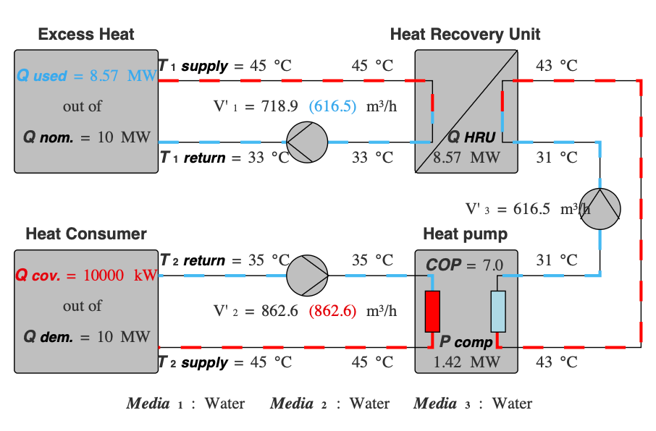

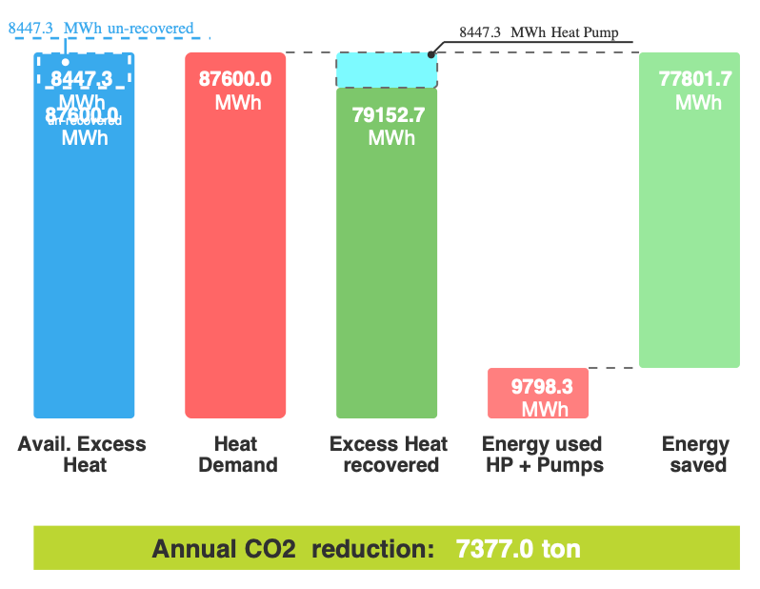

**Study 4.3 - DC at 60°C**

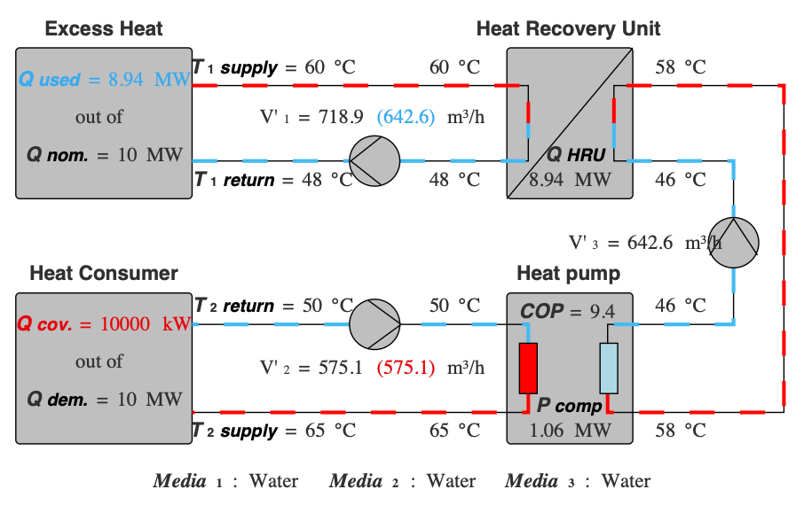

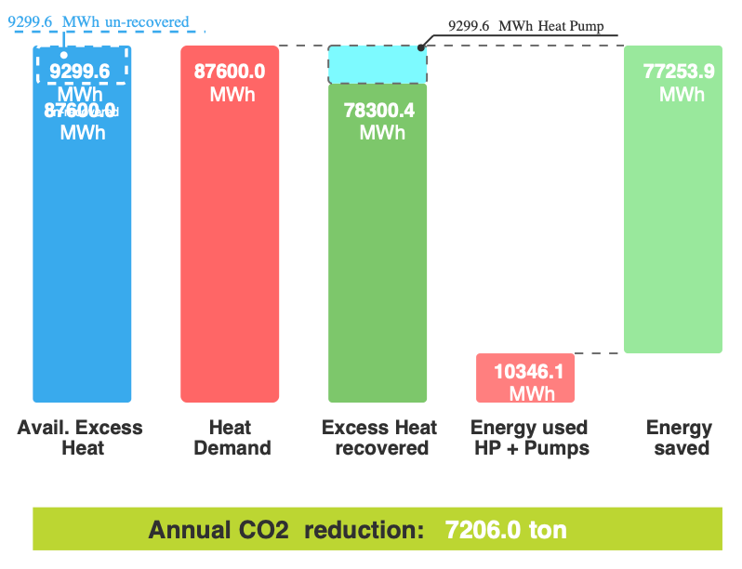

This solution, although technically complex, is the optimal choice. It allows the greenhouse to achieve precise temperature regulation—critical for crop health—by utilizing a control mixing valve. This approach successfully incorporates the high carbon reduction and energy efficiency found in theoretical models. More importantly, its design enables growers to integrate the new heat source seamlessly with their existing energy systems. The intricacy of the engineering is a worthwhile trade-off for the superior operational flexibility and sustainability provided by this essential blending capability.

### Overall Recovered Waste Heat

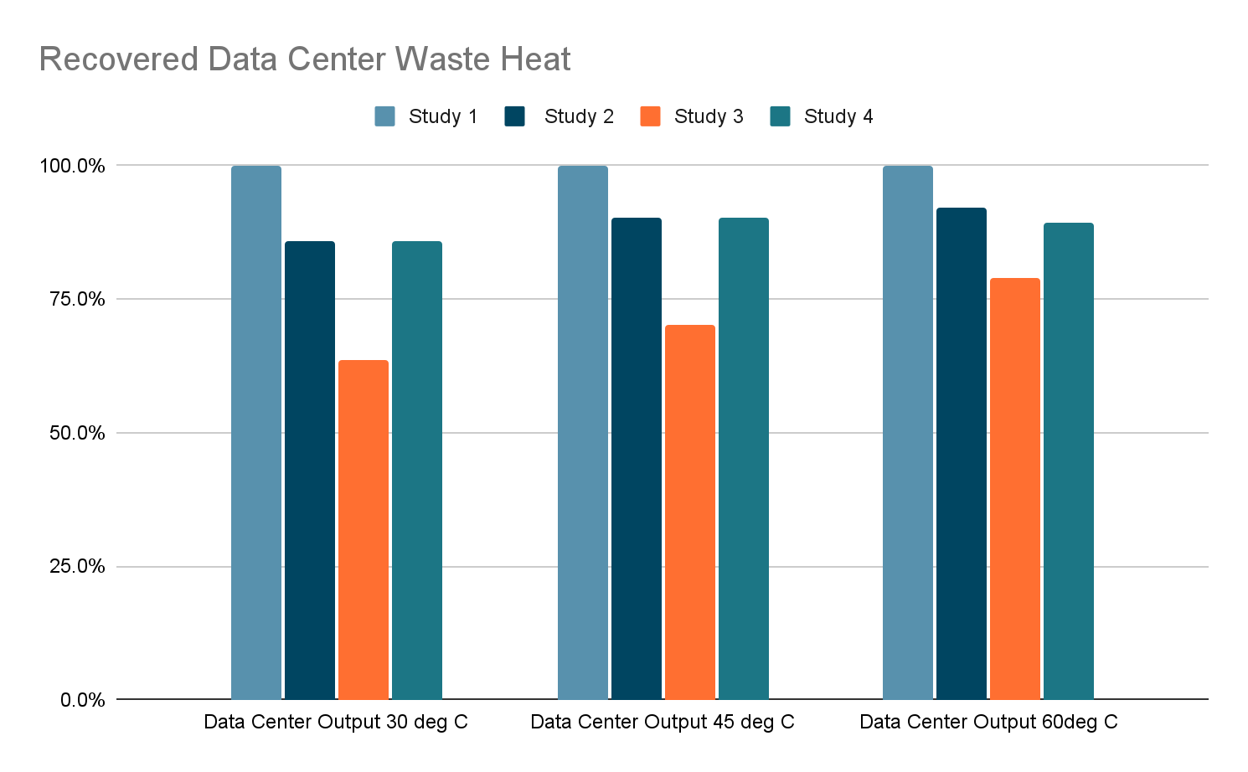

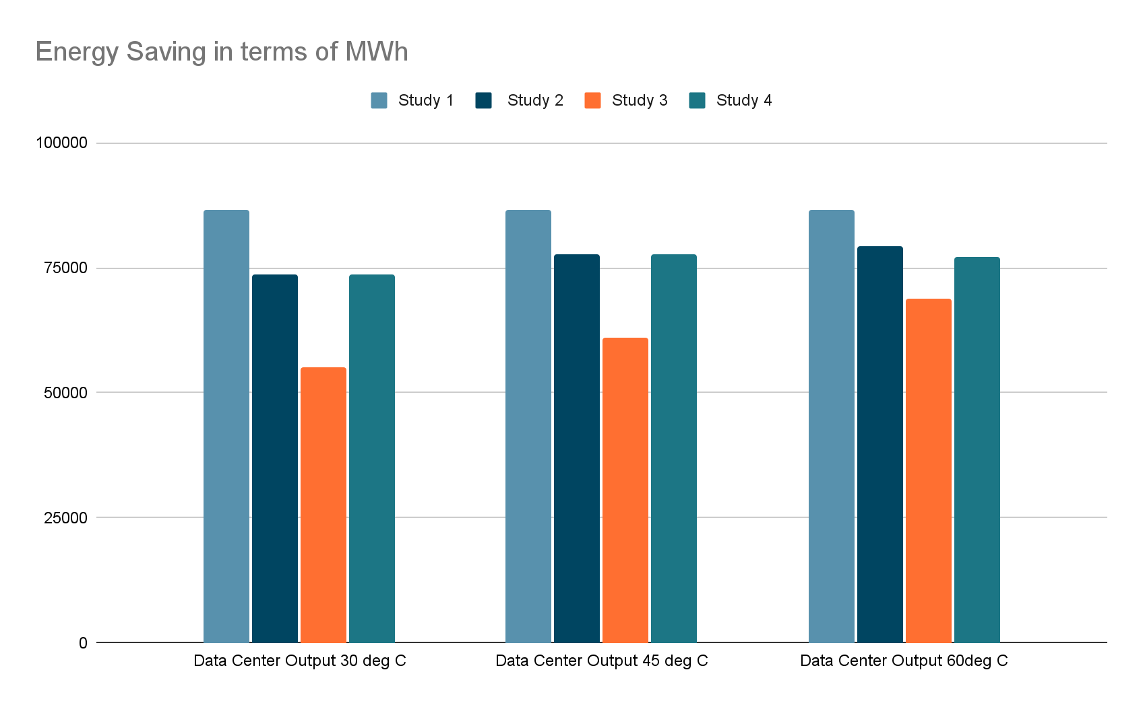

### Chart

### Economics of different Scenarios

### 

|  | **Data Centre** | | **CAPEX (k€)** | | **Annual OPEX (k€)** | | **Simple Payback Period (Years)** | |
| --- | --- | --- | --- | --- | --- | --- | --- | --- |
| **Study** | Output Temperature | Input Temperature | Data Centre (Supplier) | Greenhouse  (Consumer) | Data Centre (Supplier) | Greenhouse  (Consumer) | Data Centre (Supplier) | Greenhouse  (Consumer) |
| 1.1 | 30°C | 18°C | 3076.72 | 1025.57 | 837.08 | 6968.05 | 3.7 | 0.1 |
| 1.2 | 45°C | 33°C | 3076.72 | 1025.57 | 837.08 | 6968.05 | 3.7 | 0.1 |
| 1.3 | 60°C | 48°C | 3076.72 | 1025.57 | 837.08 | 6968.05 | 3.7 | 0.1 |
| 2.1 | 30°C | 18°C | 4559.44 | 10017.3 | 714.87 | 4874.31 | 6.4 | 2.1 |
| 2.2 | 45°C | 33°C | 4804.11 | 10017.3 | 754.27 | 5518.41 | 6.4 | 1.8 |
| 2.3 | 60°C | 48°C | 4900.8 | 10017.3 | 769.83 | 5772.86 | 6.4 | 1.7 |
| 3.1 | 30°C | 18°C | 3376.38 | 10017.3 | 524.4 | 1819.83 | 6.4 | 5.5 |
| 3.2 | 45°C | 33°C | 3729.72 | 10017.3 | 581.28 | 2749.86 | 6.4 | 3.6 |
| 3.3 | 60°C | 48°C | 4204.52 | 10017.3 | 657.72 | 3999.7 | 6.4 | 2.5 |
| 4.1 | 30°C | 18°C | 4559.44 | 10017.3 | 714.87 | 4874.31 | 6.4 | 2.1 |
| 4.2 | 45°C | 33°C | 4804.11 | 10017.3 | 754.27 | 5518.41 | 6.4 | 1.8 |
| 4.3 | 60°C | 48°C | 4752.41 | 10017.3 | 745.93 | 5406.21 | 6.4 | 1.9 |

### Complexity of Greenhouse Sizing

Greenhouse energy consumption increases significantly with latitude due to colder ambient temperatures and lower solar radiation, which necessitates more supplemental heating and artificial lighting.

Energy use is generally measured as **Energy Use Intensity (EUI)**. For greenhouses, this is often expressed in kWh/m2/y. To convert this to the industry standard of MWh/ha/y (Megawatt-hours per hectare per year), multiply the kWh/m2 value by 10.

### Typical Energy Consumption by Latitude

The table below outlines the estimated energy requirements for standard commercial greenhouses (primarily for heating and supplemental lighting):

| **Latitude Range** | **EUI (kWh/m2/y)** | **Energy Demand (MWh/ha/y)** | **Typical Heating Period** |
| --- | --- | --- | --- |
| **Lower (40–50°N)** | 250 – 430 | **2,500 – 4,300** | 5 – 6 months |
| **Higher (50–60°N)** | 430 – 650+ | **4,300 – 6,500+** | 7 – 9 months |

### 

### Key Drivers of Energy Demand

* **Heating (70–80% of total):** In the 50–60° range, the heating demand rises exponentially rather than linearly. For example, a greenhouse in Malmö, Sweden (~55°N) requires roughly 480 kWh/m2/y, whereas one in Luleå (~65°N) jumps to 676 kWh/m2/y.
* **Supplemental Lighting:** Above 40°N, natural winter light is insufficient for year-round production. High-latitude greenhouses often use High-Pressure Sodium (HPS) or LED lighting, which can add **500 – 1,000 MWh/ha/y** to the electricity load depending on the crop (e.g., cannabis or tomatoes require much more light than leafy greens).
* **Structure Type:** Gutter-connected (multi-span) greenhouses are significantly more efficient than standalone hoophouses. A gutter-connected structure can reduce heat loss by **20–25%** because it has less exposed surface area per hectare of growing space.

### 

### Regional Examples

* **40–45°N (e.g., Southern Ontario/Northern US):** Greenhouses here typically average around **3,000–3,500 MWh/ha/y**.
* **50–55°N (e.g., Netherlands/Central Germany):** Intensive Dutch greenhouses often fall into the **4,500–5,000 MWh/ha/y** range to maintain high yields in winter.
* **60°N+ (e.g., Finland/Northern Canada):** Energy needs can exceed **7,000 MWh/ha/y** if producing high-light crops like cucumbers throughout the winter.

**Peak Heating**

Peak heating requirements (the maximum heating capacity needed to maintain indoor temperatures on the coldest night) are measured in **MW/ha** (Megawatts per hectare) or **W/m2**.

Unlike annual energy consumption (MWh/ha/yr), which averages out over the seasons, peak requirements define the actual size and cost of the boiler or heating infrastructure that must be installed.

### Peak Heating Requirements by Latitude

For a standard modern greenhouse (e.g., double-layer polycarbonate or glass with an energy curtain), the peak thermal power demand varies significantly between these ranges:

| **Latitude Range** | **Typical Peak Demand (W/m2)** | **Peak Heating Power (MW/ha)** | **Est. Outdoor Design Temp** |
| --- | --- | --- | --- |
| **Lower (40–50°N)** | 150 – 250 | **1.5 – 2.5** | 10°C to -20°C |
| **Higher (50–60°N)** | 250 – 550+ | **2.5 – 5.5+** | ~ -25°C to ~ -40°C |

***Note on the "Exponential Jump":*** *Recent studies (*[*MDPI 2023*](https://www.mdpi.com/1996-1073/16/19/6788)*) indicate that while heating power scales somewhat linearly from 40° to 50°N, it begins an* ***exponential rise*** *after 50°N. This is because at high latitudes, you are not only fighting colder air but also significantly longer periods of darkness where there is zero "solar gain" to offset heat loss.*

### 

### Factors Driving Peak Load

Peak requirements are calculated using the "Delta T", which is the difference between the desired inside temperature and the absolute coldest expected outside temperature.

1. **Conduction Loss:** At 60°N, the Delta T can be 50°C or higher (e.g., maintaining +18°C inside when it is -35°C outside). This requires nearly double the "punch" from a boiler compared to 40°N where the Delta T rarely exceeds 30°C.
2. **Infiltration:** Cold air is denser and often accompanied by high winter winds at higher latitudes. This increases the "air exchange" rate, where cold air leaks in through seals, requiring an additional **0.5 – 1.0 MW/ha** of capacity just to warm up the incoming air.
3. **The "Safety Factor":** Engineers typically add a **20-30% buffer** to the peak calculation to account for extreme weather events, meaning a greenhouse at 55°N might be equipped with a 6.0 MW/ha system even if its "average" winter peak is lower.

### Infrastructure Impact

* **Boiler Sizing:** A 10-hectare greenhouse at 55°N requires a central boiler plant capable of roughly **50 MW**. At 45°N, that same 10-hectare facility might only need a **20-25 MW** plant.
* **Backup Power:** Because high-latitude greenhouses often rely on supplemental lighting during peak cold periods, the electrical peak demand (for LEDs/HPS) also spikes, often requiring **1.0 – 2.0 MW/ha** of electrical capacity on top of the thermal requirements.

### A practical example from a 10MW waste heat datacenter

In Ontario, greenhouse heating demand is highly seasonal (near zero in summer and peaking in January). Because the source is constant, there is an inherent "mismatch" that determines the optimal sizing.

### 1. Sizing Scenarios for Ontario

Based on a typical Ontario energy use intensity (EUI) of **3,500 MWh/ha/year** and a peak demand of **2.5 MW/ha**, here are the three ways to size the facility:

| **Strategy** | **Greenhouse Size** | **% of Waste Heat Utilized** | **% of Greenhouse Demand Covered** | **Backup Boiler Needed?** |
| --- | --- | --- | --- | --- |
| **Peak Match** (Small) | **~6 – 8 ha** | ~18% | 100% | No (HP covers peak) |
| **Base Load** (Optimal) | **25 – 35 ha** | **~60 – 65%** | **70 – 80%** | Yes (for extreme cold) |
| **Annual Match** (Large) | **>50 ha** | ~70 – 80% | <50% | Massive boiler plant |

### 2. The "Optimal" Recommendation: 30 Hectares

To **maximize the waste heat** while maintaining a viable commercial operation, a **30-hectare (74-acre)** greenhouse is the recommended target.

* **Total Annual Consumption:** A 30 ha greenhouse in Southern Ontario needs roughly **105,000 MWh/year**.
* **Heat Pump Contribution:** The system can supply **81,800 MWh** of that demand (utilizing **60%** of the total available waste heat resource).
* **Self-Sufficiency:** The heat pump would cover approximately **78%** of the greenhouse's total annual heating bill.
* **Infrastructure:** There would be need for supplemental natural gas boilers for the remaining 22% of energy, specifically to handle the "top-up" required during January/February nights when the peak demand for 30 ha (75MW) exceeds the heat pump's capacity (15.7MW).

### 3. Why not reach 100% utilization?

Even if a 100-hectare greenhouse was built, it would be a struggle to utilize more than **80%** of the annual waste heat resource. This is because:

1. **Summer Valley:** In June, July, and August, Ontario greenhouses require almost zero heat. Since the 10MW source is "always on," that heat must be rejected/wasted during these months unless there is a secondary use (e.g., industrial drying or seasonal thermal storage).
2. **Diminishing Returns:** Increasing the greenhouse size beyond 40 ha significantly increases the cost of the backup boiler system needed for winter, without significantly increasing the amount of waste heat that can be "captured" in the shoulder seasons.

### 

### 

### Technical Summary for Planning

* **Constant Thermal Supply:** 15.7MW
* **Target Size:** 30 hectares
* **Energy Offset:** Saves approx. 10.5 million cubic meters of natural gas per year.
* **Temperature Match:** the **91**°**C** output is ideal. It allows the use of standard high-fin radiation pipes or rail-heating systems, which are more cost-effective than the low-temp floor heating required by un-upgraded (30°C) waste heat.

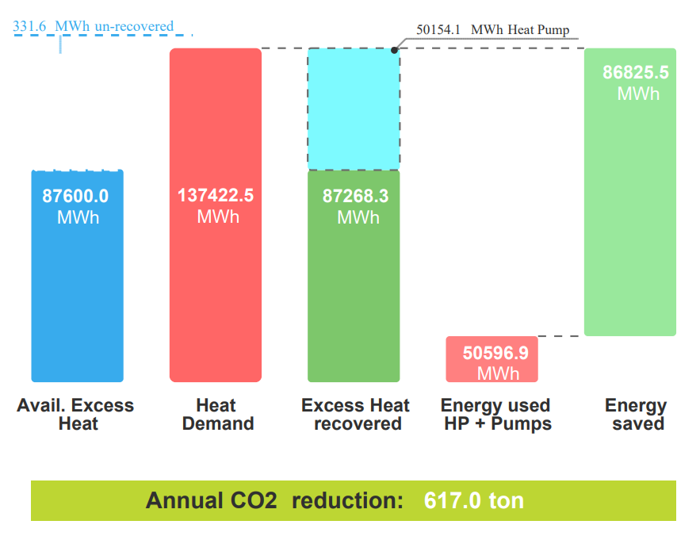

### Greenhouse Sizing Formula: The "DC-to-Food" Formula (for Peak Need)

H (Hectares) = (PDC x Nrec) / Peak Heat Demand (MW/ha)

Y (Annual Yield in Tonnes) = H x Ycrop

PDC = Data Center IT Load (MW)

Nrec = Recovery Efficiency (Typically 0.70 or 70% of IT load is recoverable as usable heat)

Peak Heat Demand = Maximum MW required per hectare based on location

Ycrop = Typical annual yield per hectare for your chosen crop (e.g., ~600 tonnes/ha for tomatoes)

Practical Example: 10 MW Data Center in Ontario

If you have a 10MW datacenter in Ontario (45N) and want to grow tomatoes:

1. Recoverable Heat: 10MW x 0.70 = 7MW available.  
2. Sizing Greenhouse: 7MW / 2.8MW/ha (avg peak) = 2.5 Hectares.  
3. Crop Yield: 2.5ha x 600 tonnes/ha = 1,500 Tonnes of tomatoes per year.

### Recommendations

At the end, each site needs to be reviewed and evaluated individually to establish the ideal heat reuse, greenhouse sizing and production facility needs.

It is clear that focusing on utilizing higher temperatures from datacenters rejected heat will have a measurable impact on the reduction of natural gas use from greenhouses. However what has a larger impact is the placement of that heat vs simply injecting that heat into the thermal storage tank from the boilers. Lower temperature thermal storage tanks should be utilized to maximize the rejected heat use. This storage has a much more meaningful impact on the heat utilization rate vs the increase in temperature of the rejected heat.

The sizing of greenhouses to data centers should be maximized to utilize all the rejected heat, but not to replace all the heating needs of a greenhouse. This will ensure commercial viability but ensure that assets are far too oversized for the peak needs, but operate to provide baseload heating needs and support ~80% of the required heat.

### Feasible Area Calculation (10 MW Basis):

| **Sizing Strategy** | **MWh/yr** | **Datacenter Heat Utilization** | **Greenhouse demand (MWh)** | **Unrecovered Heat (MWh)** | **Greenhouse Size (ha)** | **Tomato Production (tons)** | **Population: Tomato Food Secure (5.5kg/person)** | **Jobs** |
| --- | --- | --- | --- | --- | --- | --- | --- | --- |
| Peak Match | 87,600 | **19.9%** | 27,484 | 70,146 | 6.4 | 2,716 | 493,902 | 40 |
| Base Load | 87,600 | **63.5%** | 87,600 | 31,971 | 20.4 | 8,658 | 1,574,207 | 126 |
| Max Use | 87,600 | **99.6%** | 137,423 | 332 | 32 | 13,582 | 2,469,538 | 198 |

### Next Steps

Next research needs should focus around:

* Real time, real world data collections from data centre & greenhouse.
* Site specific feasibility and sizing.
* Thermal storage solutions.
* Heat Recovery System risk & reliability analysis.

**Appendix:**

Some of the additional informations

**Datacenter Heat:**

-12°C ΔT from input to Output

3 scenarios: 30°C, 45°C, and 60°C

Datacenter delivering 30°C returning 18°C to the datacenter

**Electricity:**

$80/MWh

In March 2025, the average electricity price for businesses in the Netherlands was approximately €0.208 per kWh, including all taxes and fees. However, prices for very large industrial consumers, such as a large greenhouse in Middenmeer, can be lower due to potential tax exemptions and direct purchasing agreements.

Specific rates published for energy customers at Dutch horticultural hubs in 2025 were around €0.16 to €0.162 per kWh. This specific figure is likely more representative of the costs for a large greenhouse operation.

Factors influencing the final cost per kWh for a large greenhouse include:

* Consumption volume: Large consumers often pay less per kWh than medium or small businesses.
* Taxes and levies: The effective cost is significantly impacted by non-recoverable taxes and levies, which can vary depending on specific industrial exemptions.
* Wholesale market fluctuations: Prices in the wholesale market have fluctuated, with average prices around USD 90/MWh (€80-85/MWh) in H1 2025, suggesting that very large users with direct access to wholesale markets or Power Purchase Agreements (PPAs) might achieve lower effective costs, excluding distribution fees and taxes.
* Energy source: Greenhouses increasingly use combined heat and power (CHP) units or renewable energy sources, which can alter their overall energy cost balance.

Ultimately, a large greenhouse operation in Middenmeer would likely be paying an effective rate per kWh closer to the industrial consumer price, possibly in the range of €0.15 to €0.21 per kWh depending on their specific contract terms and energy management strategies.

**Natural Gas:**

€0.0839 per kWh

As of November 2025, the cost of natural gas for a large greenhouse in Middenmeer, Netherlands, is primarily based on commercial tariffs and specific tax structures for the horticulture sector.

While precise, real-time contract prices vary, general price data for large business consumers in the Netherlands during the first half of 2025 indicated a price of approximately €0.0839 per kWh (including all non-recoverable taxes and levies).

Key factors and current market context:

* Business Tariffs: Commercial rates are typically lower than household rates, but the final price depends heavily on the specific contract type (e.g., spot market prices, which many growers use, or fixed contracts).
* Taxation: The horticulture sector has historically benefited from a reduced energy tax rate. However, the government is increasing this tax gradually. In 2025, the tax on natural gas for a large user (consuming 170,000 to 1 million cubic meters annually) is projected to be around €0.159 per cubic meter (equivalent to approximately €0.017 per kWh, assuming 1 m³ ≈ 9.5 kWh).
* Market Benchmarks: The benchmark Dutch natural gas futures (TTF Gas) price as of November 3, 2025, was around €31.83 per MWh, which translates to approximately €0.03183 per kWh on the wholesale market, before distribution costs, taxes, and supplier margins are added.
* Future Costs: The Dutch government is introducing a mandatory green gas blending requirement and including the sector in the new EU Emissions Trading System (ETS-2), which is expected to lead to increased costs in the coming years.

The final cost will be a combination of the wholesale market price, distribution network costs, taxes, and supplier margins, likely resulting in a final price to the large greenhouse operator in the range of €0.05 to €0.10 per kWh (this range is an estimate based on available data and market components).

<https://www.hortidaily.com/article/9727150/dutch-government-decision-angers-growers/#:~:text=Last%20week's%20leaked%20information%20has,national%20Recovery%20and%20Resilience%20Plan>.  
<https://www.bloomberg.com/news/articles/2021-09-30/your-tomatoes-may-cost-more-as-gas-prices-hit-dutch-greenhouses#:~:text=Farm%20Trade%20Titans,the%20year%2C%20toppling%20prior%20records>.

<https://cedelft.eu/publications/evaluation-of-an-energy-charge-tariff-for-greenhouse-horticulture/#:~:text=Greenhouse%20horticulture%20currently%20enjoys%20a,incentive%20fund%20for%20greener%20energy>.

<https://www.hortidaily.com/article/9561287/prinsjesdag-budget-cabinet-comes-to-take-money-from-horticulture/#:~:text=or%20%E2%82%AC243).-,Boiler%20gas,here%20to%20enlarge%20the%20table>.

<https://ec.europa.eu/eurostat/statistics-explained/index.php/Natural_gas_price_statistics#:~:text=Then%2C%20it%20decreased%20every%20semester,(%E2%82%AC0.0531%20per%20kWh)>.

<https://tradingeconomics.com/commodity/eu-natural-gas#:~:text=TTF%20Gas%20Hits%204%2Dweek,the%20US%20and%20Middle%20East>.

**Greenhouse Warming**

Cucumbers and lettuce from this greenhouse have a GWP of 0.178 and 0.453 kg CO2eq per kg product. Considering credits from additional electricity production at the waste incineration plant, total emissions are -0.098 and -0.368 kg CO2eq per kg of cucumbers and lettuce, respectively Lower global warming potential of cucumbers and lettuce from a greenhouse heated by waste heat

<https://www.researchgate.net/publication/267296616_Lower_global_warming_potential_of_cucumbers_and_lettuce_from_a_greenhouse_heated_by_waste_heat>